**Memory and Learning**

**Def. Memory**: storage, encoding and retrieval of information in the nervous system.

**Def. Learning**: process by which information, sills, behaviours are acquired or existing information, skills etc. are changed. Learning is a change in the nervous system caused by some event that in turn changes behaviour.

Two types of memory storage systems:  
Declarative memory (involved hippocampus and amygdala; hippocampus necessary for long term memory formation (not needed for retrieval specifically, but it is indispensable for the formation of long term memory) – memories include events, episodic memory, language, words, meaning of words, recognition and other consciously accessible memory data).  
Non-declarative memory (neural substrates of their formation unknown, but assumed to be widespread; includes motoric functions, associations, puzzle solving skills, priming cues etc. – storage is in cerebellum, basal ganglia, premotor cortex and other sites related to motor activity).

Non-associative learning: exposure to a stimulus over time changes the reaction/response to it eventually (🡺 habituation, sensitization, adaptation).

**Patient H.M.**

Removal of both hippocampus and amygdala 🡺 could not form new memories, but previously established memories were left unaffected. Non-declarative memory formation was left unaffected as well as working memory, IQ, abstract thinking and other cognitive functions. Patient HM was not able to form declarative memory anymore.

**Multiple memory trace theory**: Short-term and long-term memory have both independent pathways that can be blocked selectively and work in parallel. Long-lasting memory results through the interaction, reorganization and stabilization of different distributed connections concerning brain systems.

**Equipotentiality**: There is no specific location for memory. Memory is distributed over brain systems and lesions of one area specifically does not necessarily disrupt the memory and thus it can be still retained.

**Consolidation**: The transfer of a memory from short-term memory to long-term memory.

**Concept cells (in the hippocampus)**

Neurons that only fire when they are exposed to a concept. A concept can be a face, hearing of a name, reading the name. Ex.: The same cells fire to Jennifer Aniston when they see a picture of her or hear her name etc.  
Most likely, it is a concept network of several cells. A concept can be an arbitrary concept which activates the firing of these cells (resp. networks).

**Basal Ganglia**

There is no apparent amnesia, but problems in **procedural memory** occurs which involves skills, habits, perceptual motor learning etc.

There is non-declarative memory that is dependent of implicit memory. Likewise, there is non-declarative memory that is not dependent on the basal ganglia (fear learning, motor responses, priming).

**Fear learning**

Central nucleus of amygdala = unlearned fear response (UR).  
Basolateral/lateral nucleus of amygdala = learned fear (CR). A learned fear response also passes the thamalus first, while an unlearned fear response need not.

**Neural substrates of working/short-term memory**

**Hebb’s Theory of Consolidation**: There are cell assemblies that code information and is used for short-term memory. Persistent activation establishes from a short-term network to become a long-term network. In this long-term network, a cell/unit has synapses strong enough to activate the other units or subnetworks. Associations between several networks is conceivable that the activation of one network activates the other.

Sleep: restoration/cleaning of molecular rubbish, synaptic normalization.

(**Artificial neural network part: NOT SURE IF RELEVANT**)

**Visual System**

**Facts about the retina**: Rods are extremely sensitive. They register every single quantum of light. Cones need more to become active. +20° from the fovea is the blind spot, where there are no photoreceptors. Also, in the fovea, there are no rods and only M and L cones for maximal resolution. Cone density very quickly decreases as one moves farther away from the fovea, while rods density increases. It should be noted that resolution in the periphery is really bad.

S cones relative maximal absorbance = 437 nm  
M cones relative maximal absorbance = 533 nm  
L cones relative maximal absorbance = 564 nm  
Rods relative maximal absorbance = 498 nm

At least two cone types are needed for colour impression, since the brain performs computations based on comparing inputs from different cones. A response of a cone can be due to optimal wavelength or due to intensity of a less optimal wavelength. Thus, the brain does not receive unique wavelength information from neither cone nor rod (which is why we have no night colour vision – only 1 type of rods present).

Optic nerve is a collection of around 1 million ganglion cells. The ganglion cells are the first to produce an AP – all previous cells mostly communicate via chemical signals. Since the cones and rods are at the back of the cell, all previous cells are transparent.

**Receptor fields and LGN**

Colour pairs: blue-yellow and red-green. Both combinations can be in the surround or center as ON or OFF. These cases are found in the parvo layer of the LGN (P cells). In the magno layer of the LGN, we only find black-white (for light intensities) with ON or OFF centers/surrounds.

The LGN projects ipsilaterally to the V1 which is retinotopically organized.

**Def. Ocular dominance columns**: Cells in a column in cortical areas that prefer the same eye. There are also **orientation columns**. These are cells that prefer a certain orientation of a bar in the V1.

**Complex cells** are excited by both increase and decrease of light intensities (ON/OFF is overlapping). They are interested in **changes** in light intensity rather than in actual light intensities. Complex cells are the majority of cells in the V1.

The parietal pathway is the where-pathway: it understands the relative distribution of objects and creates a sense of spatiality. The temporal pathway is the what-pathway: it understands what one is looking at.

**Auditory system**

**Facts about the auditory system**

Measure in dB: dB = 20 * log(P1/P2), with P2 = 20 micropascal. Humans are most sensitive around 4000 Hz, since human speech occurs mostly around these frequencies. Mathematically, we can perform a Fourier analysis on this waveform and obtain the coefficients. Also, we can add infinitely many odd frequencies to obtain a square wave.

The Eustachian tube (part of middle ear) has only air and no liquid in it. Cochlea (part of inner ear) has a liquid inside, the ossicles match the impedance of the air and liquid in the cochlea, such that transduction can happen. Ossicles also play a protective role. Inner HC are found in the organ of corti and signal to the brain. Outer HC detect the presence of sound and also play a protective role. The organ of Corti on top of the basilar membrane contains these cells. The basilar membrane metaphorically performs a Fourier analysis.

When the organ of Corti moves upward, the stereocilia bend away from the limbus and they depolarize. When the organ of Corti moves downward, the stereocilia bend toward the limbus and they hyperpolarize.

**Mechanical transduction in hearing**: A HC has a tip link that is linked to a K+ channel of another stereocilia. When this tip link is bent away from the limbus, it mechanically opens the other channel and thus, K+ flows in 🡺 depolarization 🡺 Ca2+ also flows in and acts as a second messenger.

When tip link is bent towards the limbus, it mechanically closes the channel 🡺 hyperpolarization.

The endolymph contains a high K+ and is electrically positive. The hair cells also contain a high K+ but are electrically negative (Na/K pumps). Hence driving force for K+ into cells.

The cell bodies of the auditory nerve fibers are located within the spiral ganglion. Their axons join those from the vestibular apparatus to form the vestibulocochlear nerve.

For conscious hearing to happen, we need several auditory nerve fibers to be active. Only one will not result into actual hearing.

The cochlea as well as the auditory cortex are tonotopically organized. Low frequencies are discriminated by firing of the auditory nerve fibers with the same frequency as the sound. As the amplitude of vibration increases, a larger proportion of the basilar membrane vibrates, causing more and more of the hair cells to move. This leads to spatial summation of impulses and transmission through a greater number of nerve fibers.

**Discrimination of “sound patterns” by the 1 & 2 auditory cortex**: Destruction of both (but not one) 1 auditory cortices will reduce greatly one’s sensitivity to hearing. Interpretation of the meanings and sequence of sound tones in the auditory signals happens in the 2 auditory cortex.

**Com**: “**timbre**: combination of different frequencies - same note does not sound the same in different instruments. each instrument produces many different freq. there is a dominating pitch, but there are side frequencies that also influence the final experience of that sound and therefore they shape the final outcome, even if the same note is played on both instruments.”

Intensity of loudness is measured on a logarithmic scale. Loudness is not only influenced by the intensity of a sound, but also by attention, frequency, harmonics etc.

**Cocktail party effect**: During a party, we can ignore all other conversations and only listen to a single conversation and focus on it.

**Auditory localization**

**Binaural cues**: Binaural cues are robust, but they are ambiguous. An eccentrically located sound source will arrive slightly later and weaker at the other ear.

* **Interaural time difference (=: ITD)**: Humans can detect 10 microseconds in time difference. For a given ITD, its phase is a linear function of frequency. Pure tones have an ambiguous ITD. These ITD are integrated over a time window of 100-200 ms. Low to moderate frequencies, the phase differences can be easily detected.
* **Interaural intensity difference (=: IID)**: The head shadow reduces the intensity of a sound. Thus, one ear will perceive the source with slightly lower intensity. This effect is especially pronounced for high frequencies. IID is most effective at 2000 Hz and IID of less than 1 dB is detectable.
* **Cone of confusion**: Without moving our head, we can extend a cone from the ear. In this cone, we cannot uniquely localize a sound (if we do not move our head). In this cone of confusion, the same ITD and IID can arise.
* **Toroid of confusion**: If a sound source is 1 meter or less from the observer, there are high IID differences. The intersection of these near fields cones of confusion results into toroids of confusion.

**Spectral cues**: Head shadow and shape of outer ear (pinnae) create frequency dependent attenuations of sounds (they basically slightly change the sound due to the shape of outer ears). These effects are predominant at higher frequencies. This shaping effect is involved in the direction estimation. Due to unique forms of the outer ears in all individuals, these effects reflect large differences in spectral cues.

**Somatosensory system**

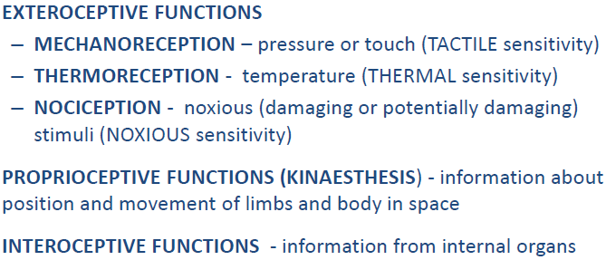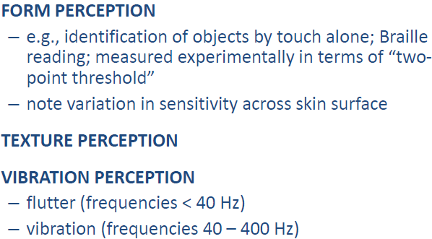

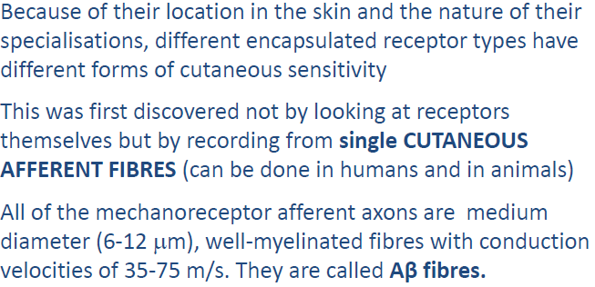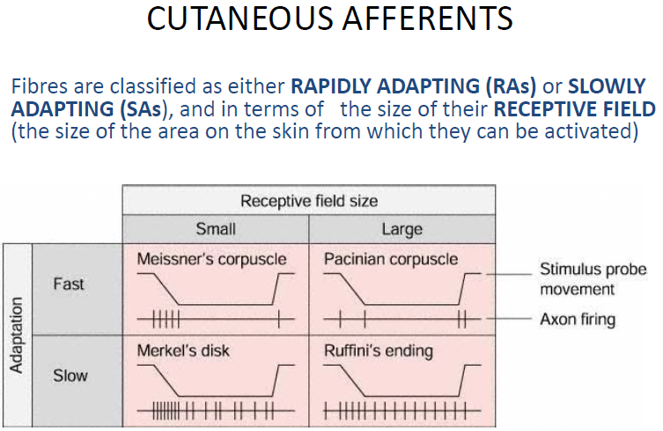

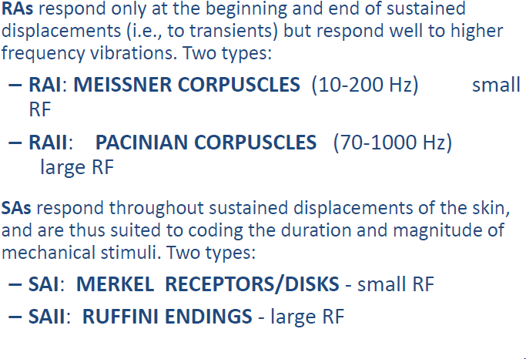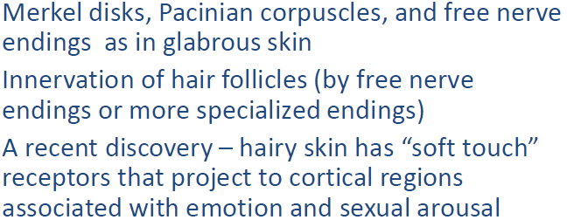

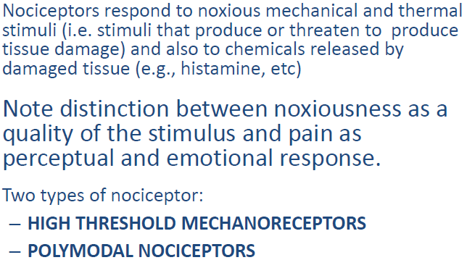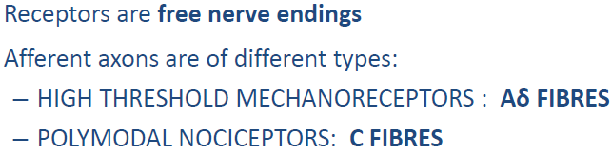

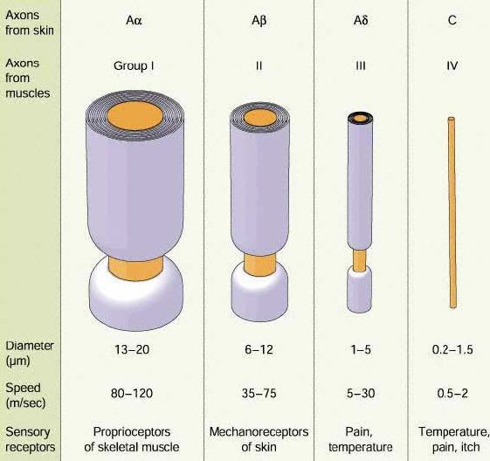

Different fibre types give rise to different pain sensations:

–“First” or “cutaneous pricking” pain – mediated by Aδ fibres (myelinated, fast, spiking activity)

–“Second” or “burning” pain - mediated by C fibres (not so myelinated, longer duration of pain)

**Thermoception**

Thermoreceptors: “WARM” fibres and “COLD” fibres. They respond to increase or decrease in temperature, respectively, from steady state and to maintained temperature.

At intermediate skin temperatures (approx. 30-35 deg) there is ongoing discharge in both warm and cold fibres, and a change in skin temperature reciprocally modifies the discharge in the two fibre types. At a lower adapting temperature (e.g., 26 deg) only cold fibres are active, and an increase in temperature first decreases the discharge in cold fibres, and them – with larger increments – begins to engage the previously silent warm fibres. They have large receptive fields, so temperature sensations are not well localized. Note relativity of thermal sensations (i.e., change in temperature is what is felt as warm or cold) and similar relativity of neuronal responses. Receptors are free/bare nerve endings.

Afferent axons: Warm fibres: C fibres; Cold fibres: Aδ fibres

**Prioprioception**

Proprioceptive information supplements “efference copy” information from motor system.

Information is provided by three classes of receptors: CUTANEOUS MECHANORECEPTORS, JOINT RECEPTORS, MUSCLE SPINDLES AND GOLGI TENDON ORGANS.

CUTANEOUS MECHANORECEPTORS: Information about skin stretch from Ruffini/ SAII afferents. Of different importance in different regions (important around hands, mouth and feet).

JOINT RECEPTORS: Ruffini-type endings and Pacinian corpuscles in joint capsule. But not essential, because anaesthesia or removal of joint capsules does not result in loss of limb position sense.

[**NOT FINISHED YET**]

**Vestibular system**

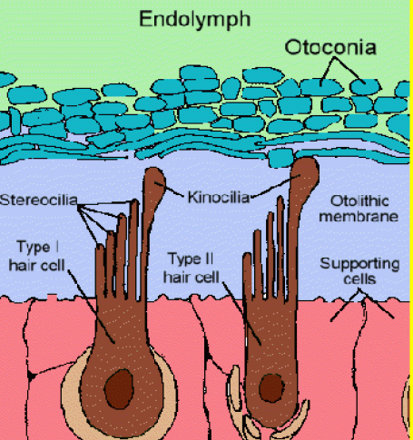Otolithic organs = saccule(vertical orientation, response to sagittal acceleration) + utricle(horizontal, +30deg orientation). In the saccule and utricle, we have ocotonia that form a layer on the type 1 and 2 hair cells (=: HC). Otoliths register static tilt and linear acceleration.

Vestibular signals first interact with other sensory signals in the vestibular nuclei (=: VN) and only a fraction of these signals is passed on directly to the VN.

Vestibulo-ocular reflex: rotation of head movement moves the eyes in the opposite direction, such that the image remains static.

Dizziness leads to vertigo (disturbance of vestibular functions) or to disequilibrium(which is a neurological disorder that can result into **cerebellar dysfunction**).

**Chemical sense**

Facts: human has 5k taste buds and 40 million olfactory cells, while dog has 1 billion olfactory cells.

Most of the tongue is sensitive to all tastes, while sweet is most frontal, then salty, sour and bitter at the back. The papillae are the taste sensitive structure which contains the taste buds (several hundred) that have receptors (50-150) for molecules. Average person: 2k-5k taste buds, super-tasters 20k, non-tasters only 500 taste buds.

The **umami taste**, which is glutamate, can bind to the ion channels, that allow inflow Ca2+ and Na+, while the other tastes bind to their receptors. There, cAMP is activated, leading to an influx of Ca2+ and Na+.

**Gourmet flavour**: The colour, texture, aroma, expectations, temperature, and satiety all play a role in the perception of taste along with the direct activation of the primary tastes. Lack of smell makes it hard to distinguish between apple and onion.

**Capsaicin**: Capsaicin (main ingredient of spicy food) binds to nociceptors and releases substance P. Substance P is synthesized by nociceptors causing vasodilation and release of histamine. It can also cause hyperalgesia.

**Smell – olfaction**

Humans can distinguish several 100k smells, only 20k are pleasant, 16-20 are identifiable. Smokers have a dulled sense of smell: pleasant are less pleasant, unpleasant are less unpleasant.

Olfactory receptors are ciliated epithelial cells capable of detecting thousands of different odours. There is **no direct** projection to the thalamus (unlike all other senses), but the olfactory bulb projects to the thalamus(?).

Primary olfactory cortex – ventral anterior temporal: detects changes in smells.  
Secondary cortex – lateral orbitofrontal cortex: identifies smells.

Projection pathway: olfactory epithelium 🡺 olfactory bulb 🡺 pyriform cortex (first perception of odour) 🡺 amygdala 🡺 thalamus (medial dorsal nucleus) 🡺 orbitofrontal cortex (conscious perception of odour or identification of it). Limbic system: emotional, appetitive, and reproductive aspects of odor.

Olfactory receptors continually die and regenerate in a cycle that lasts about 1-3 mos. Mucus (snot) covers the epithelium, flows constantly & is replaced every 10 min. (contains antibodies to protect from viruses; provides moisture and removes foreign material from inspired air).

**Pheromones**: Airborne chemicals released from animals that have a physiological or behavioural effect on another. They act on the vomeronasal organ (=: VMO). Very potent in insects. In mammals, less potent, but increasing evidence, even in humans.

* McClinton effect: synchronization of menstrual cycles of women that live together.
* In mice, same effect observed: pheromones from a certain stage of a cycle of a female mouse can shorten or lengthen the cycle of another mouse, depending on the pheromone.
* Bloodhounds have troubles distinguishing smells of identical twins.

**Synesthesia**: The capacity to join sensory experiences across sensory modalities. 1:25000 people affected. Genetic compounds undetermined.

**Autonomous nervous system**

ANS coordinates without conscious instructions the following functions: urinary, cardiovascular, respiratory, digestive, reproductive.

SNS and ANS are both afferent divisions: ANS controls visceral effectors, SNS controls skeletal muscles.

Preganglionic fibers (axons of preganglionic neurons) leave CNS and synapse on ganglionic neurons. Autonomic ganglia are peripheral, contain many ganglionic neurons and innervate visceral effectors (cardiac and smooth muscles, glands and adipose tissue). Postganglionic fibers begin at autonomic ganglia and extend to peripheral target organs.

ANS = sympathetic(exercise, stress, emergency) and parasympathetic(rest, sleep, relaxation) division + ENS.  
=> all organs are innervated by both divisions and controlled by them. Other structures may be innervated by only one or both divisions (controlling stages of complex processes).

**Sympathetic division**: Preganglionic fibers (thoracic and superior lumbar) synapse in ganglia near spinal cord, Preganglionic fibers are short, Postganglionic fibers are long.

* Stimulates metabolism, prepares for flight or fight, increases alertness
* T1 – L2 segment: collateral ganglia are unpaired (innvervate organs), sympathetic chain ganglia and adrenal medulla are paired.
* Adrenal medulla is not innervated by post-ganglionic fibers (pre-ganglionic fibers synapse on **neuroendocrine cells**), but release hormones directly in blood stream, while the other two are innervated by post-ganglionic fibers.
* Adrenal medulla releases epinephrine, affecting alpha and beta cells throughout the body (these work through G proteins).
* Axons enter ventral roots of segments and ganglionic neurons are near vertebral column.
* Cell bodies of preganglionic neurons are located in the lateral gray horns.

**Parasympathetic division**: Preganglionic fibers originate in brain stem and sacral segments of spinal cord, Synapse in ganglia close to (or within) target organs, Preganglionic fibers are long, Postganglionic fibers are short.

* Stimulates visceral activity, conserves energy and sedentary activities.
* Autonomic nuclei are contained in mesencephalon, medulla oblongata and pons.
* S2-S4 in lateral gray horns.
* Preganglionic fibers synapse on 6-8 ganglionic neurons.
* Cranial nerve X, also known as vagus nerve, innervates most organs such as heart, lungs, kidney, liver etc. (actually all organs that are not in the head, such as eye and salivary glands).
* Vagus nerve provides 75% of all parasympathetic outflow. Branches may intermingle with sympathetic fibers.
* Effects are localized (no global effects) and last a few seconds mostly.
* Neurotransmitter is always Ach. Effects vary widely though.

**Enteric nervous system (=: ENS)** is the third division of the ANS. ENS has an extensive network in digestive tract walls, ca. 100 million neurons, complex visceral reflexes are coordinated locally and all neurotransmitters are found in the brain.

Parasympathetic division only innervates visceral structures, while the sympathetic division has a widespread impact and reaches organs and tissues throughout the body.

**Autonomic tone**: Nerve is inactive under normal conditions 🡺 can only increase in activity. Nerve has baseline activity 🡺 can increase or decrease activity.